**Learning Objectives**

* To grasp usages of P, h1–h6 and hr tags;
* To grasp usages of order list, unorder list and definition list;
* To grasp several writing methods of citation;
* To grasp usages of preformatted text pre tag;
* To grasp selection method of tags;
* To grasp usages of highlighting tags;
* To grasp usages of subscript and superscript;
* To grasp how to insert and delete a tag;
* To grasp commonly used character entities.

**Learning Contents**

* P tag indicates a paragraph. It indicates a complete paragraph semantically and is a block element.
* h1 – h6 indicates the first level header to the sixth level header. The first level header is the biggest and the sixth level header is the smallest. All of them are block elements.
* hr element indicates a splitting line, which can separate paragraphs and headers.
* Examples of p, h1 — h6 and hr tags are show as below: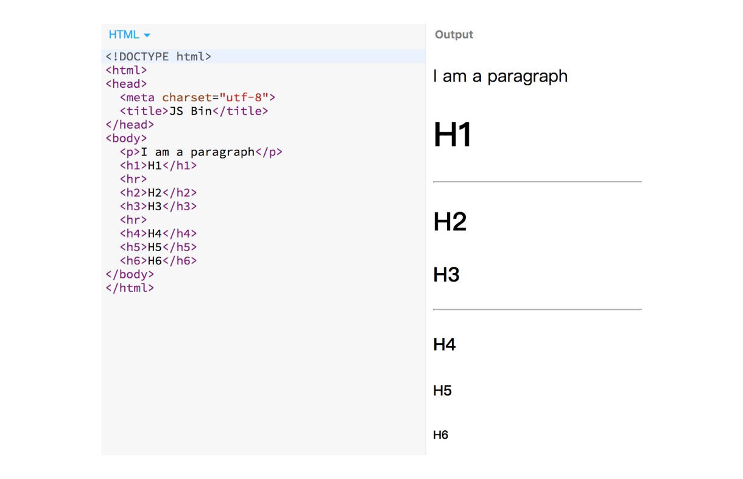
* Order list is wrapped with an ol tag and each item is indicated with a li tag.
* Unorder list is wrapped with a ul tag and each item is indicated with a li tag.
* Definition list is wrapped with a dl tag, in which dt (definition title) refers to the title of the definition and dd (definition description) refers to specific contents of the definition title.
* Examples of order list, unorder list and definition list are given as below:

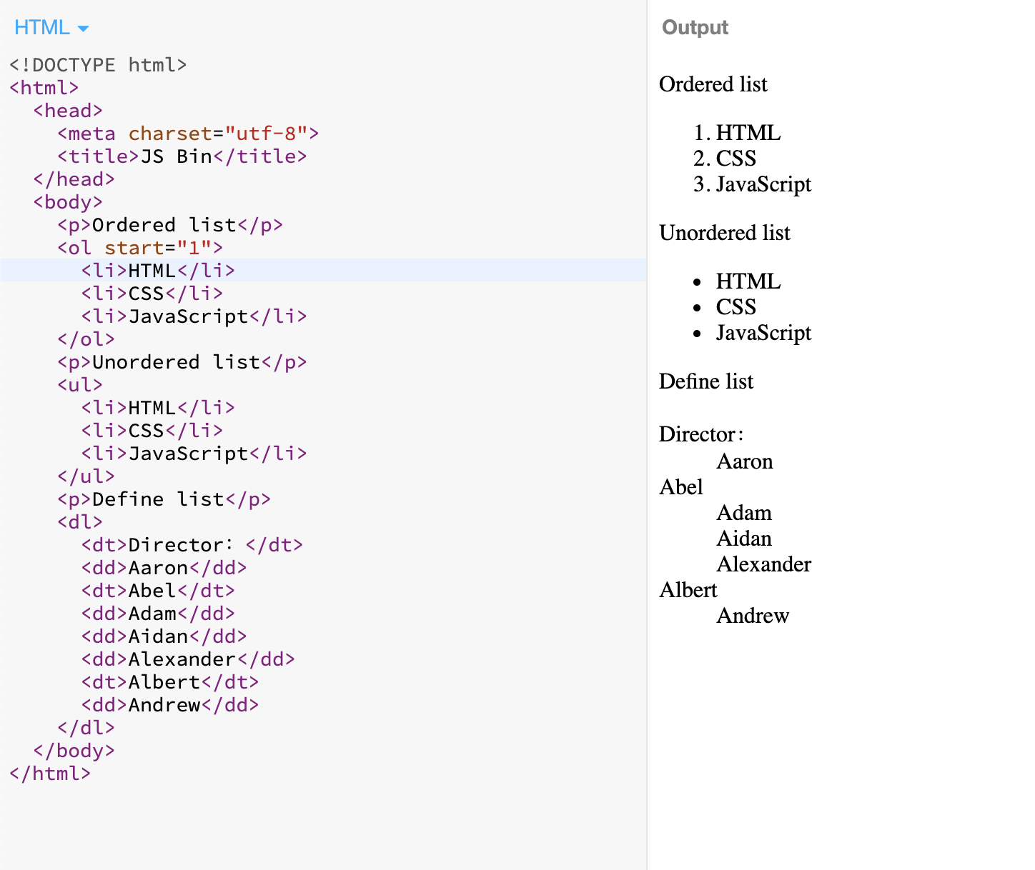

* Citation can be written in the following three ways: <blockquote>, <cite> and <q>. <blockquote> tag suggests an indentation of paragraph; <cite> tag suggests slanting contents; and <q> tag suggests double quotation marks added to the quoted contents. Their examples are given as below:

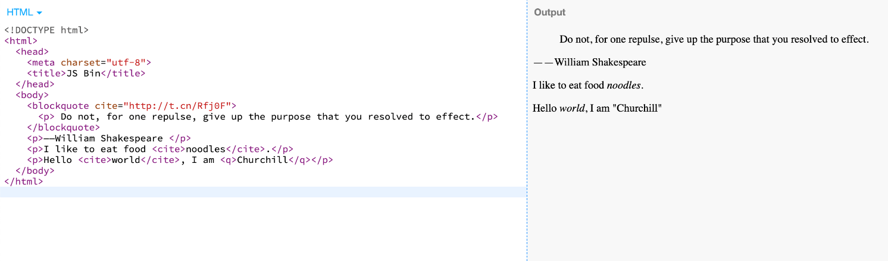

* Preformatted text uses a <pre> tag, which helps to retain the text format in the tag. Here is an example:

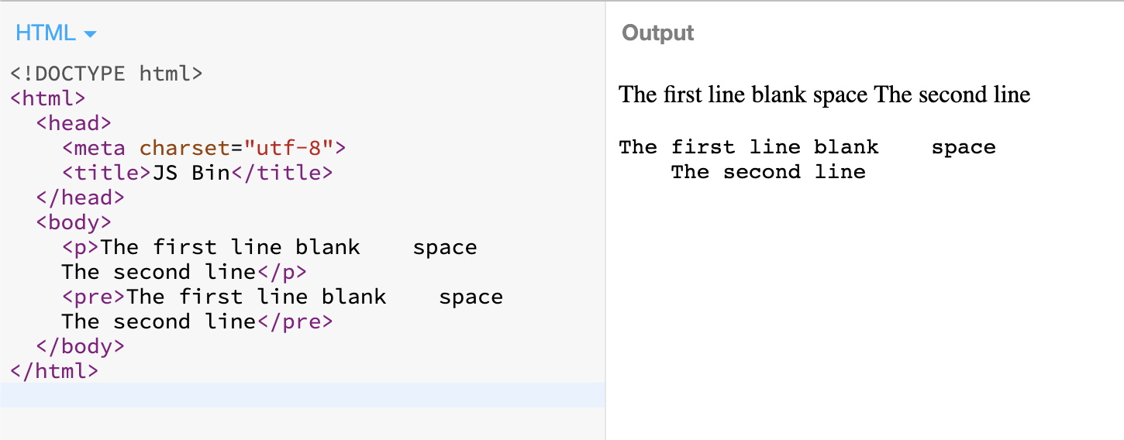

* There are so many tags. How can we select an appropriate one? You may refer to the following method: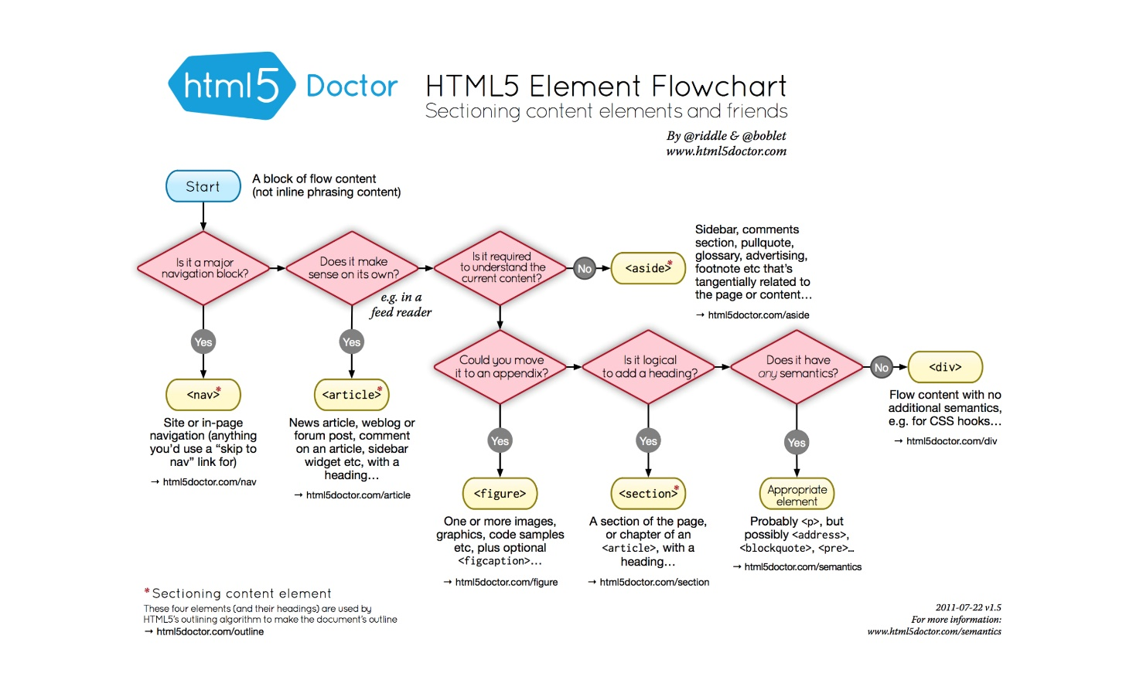
* Here are the application scenarios of several highlighting tags in HTML tag:
  + strong: Importance, severity and urgency;
  + em: To highlight a word in a sentence;
  + b: To distinguish a word with other content visually, e.g. key words in the abstract of a paper;
  + i: To state a sentence in another tune, e.g. translation in other languages or aside in a dialogue.
* In HTML, we use <sup> and <sub> to indicate superscript and subscript respectively. For example: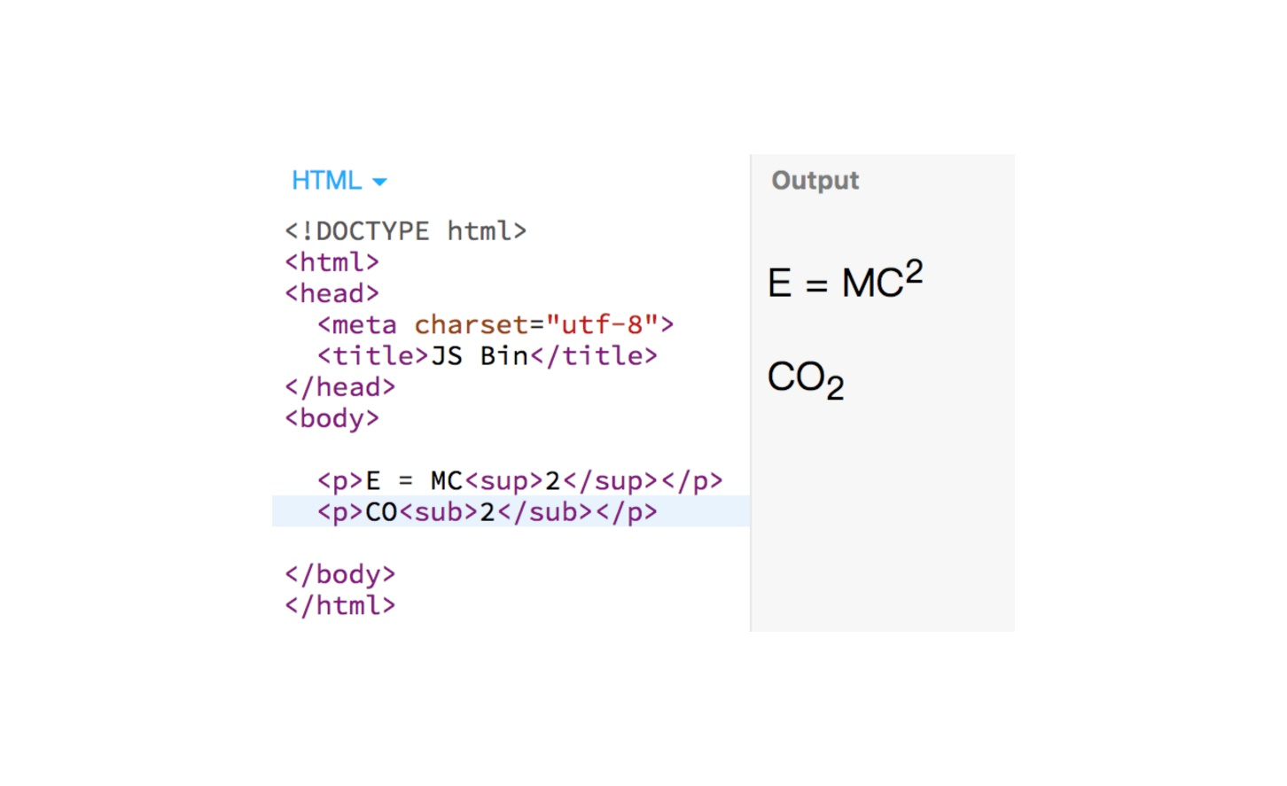
* In HTML, we use <del> and <ins> tags to indicate insertion and deletion. For example: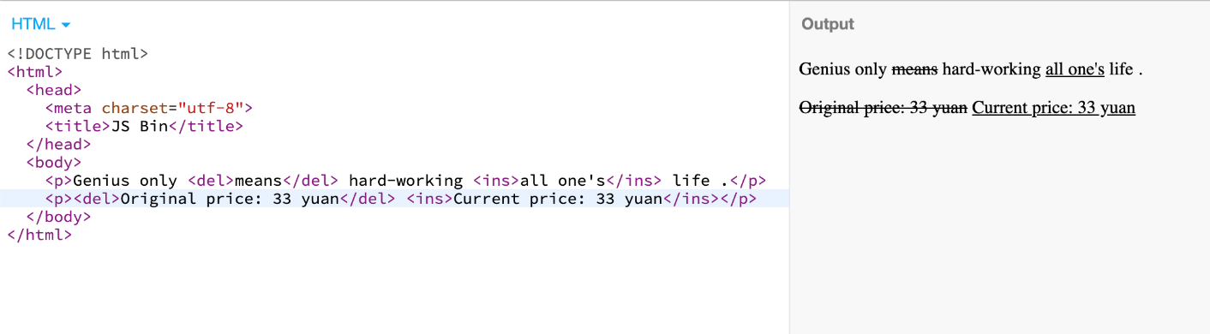
* In HTML, reserved characters cannot be output directly. They must be substituted with character entities. Common character entities include: &,  , <, >, ©, ¥ and ☯. For example: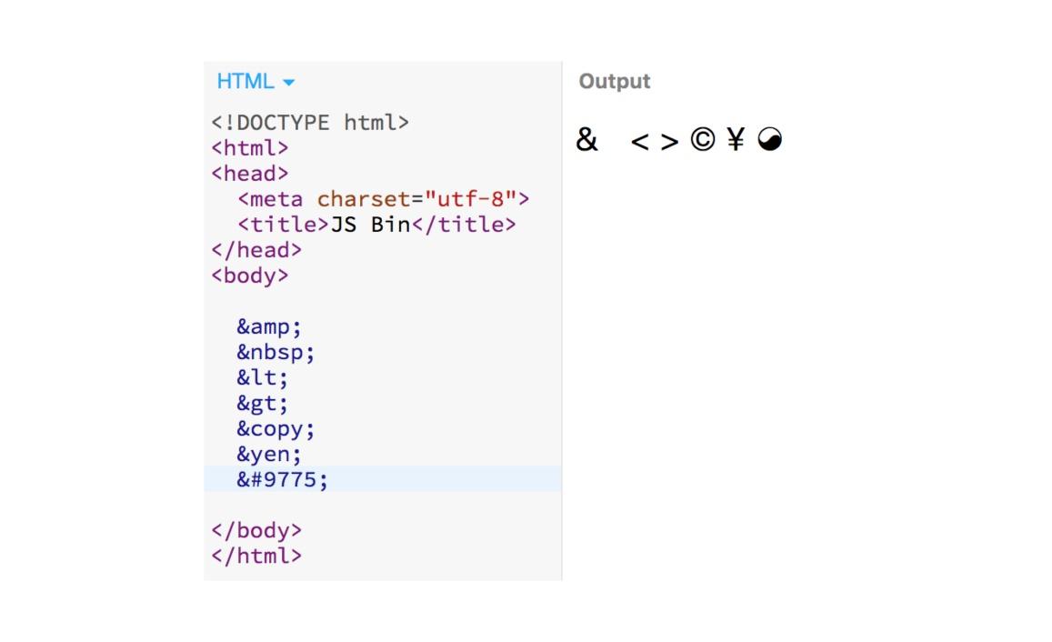

**Recommended Resources**

* HTML5 Tutorial (<https://www.w3schools.com/html/html5_intro.asp>)
* HTML Text Elements (<https://www.w3schools.com/html/html_formatting.asp>)